Eduweb College
Word Exercise

What Is the Moon Made Of?
The Moon is a differentiated world. This means that it is made of layers with different compositions. The heaviest materials have sunk down into the Moon’s center, and the lightest materials have risen to the surface.

The Lunar Core
At the Moon’s center is a dense, metallic core. This core is largely composed of iron and some nickel. The Moon’s core is relatively small (about 20% of its diameter) compared to other terrestrial worlds (like Earth) with cores measuring closer to 50% of their diameters.

The Lunar Mantle and Crust
Above the core are the mantle and crust. Differences in compositions between these layers tell a story of the Moon being largely, or even completely, composed of a great ocean of magma in its very early history.

PRACTICAL 1
- Change the font type to “Lucida Calligraphy” and size to 14
- Align the first paragraph to the right margin.
- Save this file in “My Documents” folder using the “Save As” option. Use your name as the filename. Use the file extension “.docx”.
- Highlight “The Lunar Core”
- Underline the “The Lunar Mantle and Crust” using Underline option.
- Save again using “Save” option.
- Close the file.
- Open this file again using the appropriate “File” menu option.

PRACTICAL 2
- In the same document, use the “Insert > Table” menu option to insert the following table:
Roll No. | Name | Course
1 | John | Word
2 | Joe | Excel
3 | Mary | Access

- Select the last row of the table and delete the entire row.

PRACTICAL 3

- Within the word application, search for a picture online
- Insert the picture into the centre of the page.
- Change the size of the picture by pressing right click of the mouse on the picture.

Submitting your Answer Sheet
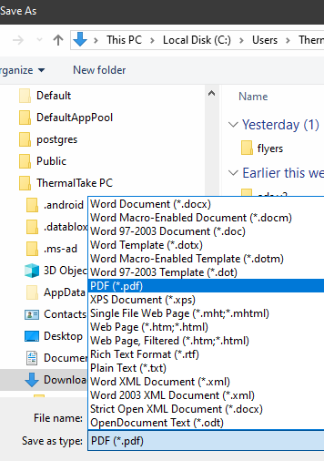
- Save your work by selecting File > Save
- Save your work as a .pdf by selecting File > Save As option. In the dialog box, choose to save the file as a .pdf
- Upload the file and send a WhatsApp message to:
868-318-7679 or
868-774-6815

Please allow 24-48 hours for a lecturer to check your submission and get back to you.

Thank you.

