**Eduweb College**

**Excel Exercise**

1. Open up Microsoft Excel.
2. 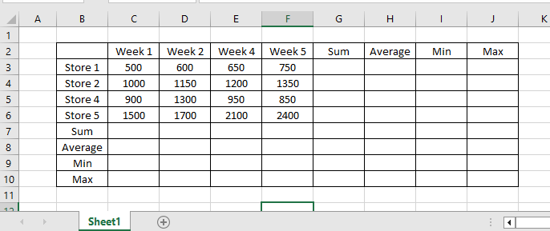Type in the following data:

Table 1 Stores

1. Save this file in “My Documents” folder using the “Save As” option. Use your name as the filename. Use the file extension “.xlsx”.
2. Rename Sheet1 to **Stores 1 to 5**
3. Using “Table 1 Stores", calculate for each WEEK the
   1. sum,
   2. average,
   3. minimum value and
   4. maximum value
4. Using the saved work of “Table 1 Stores" calculate for each STORE the
   1. sum,
   2. average,
   3. minimum value, and
   4. maximum value,
5. 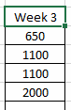Using the saved work of “Table 1 Stores" insert Week 3 with the following information:

|  |  |  |  |  |  |
| --- | --- | --- | --- | --- | --- |
| Store 3 | 2100 | 1800 | 1900 | 1800 | 2000 |

1. Using the saved work of “Table 1 Stores" insert Store 3 with the following information:
2. Recalculate sum, average, min and max for each week and store
3. Go to the bottom of the spreadsheet and right click on Sheet1
4. Rename Sheet1 to “Store Sales”
5. Format the numbers in Store Sales to include a dollar sign $
6. Format the numbers to 2 decimal places
7. Format the numbers with the comma style
8. Center all your data
9. Week 1 – 5 should be in RED, BOLD LETTERS
10. Store 1-5 should be in YELLOW FILL COLOR
11. All SUM figures should be underlined
12. The AVERAGE results of Week 1-5 should be in a light Gray Fill
13. The MAX results of Week 1-5 should be in a Rose Fill
14. All fonts should be ARIEL and size 12

**Submitting your Answer Sheet**

* 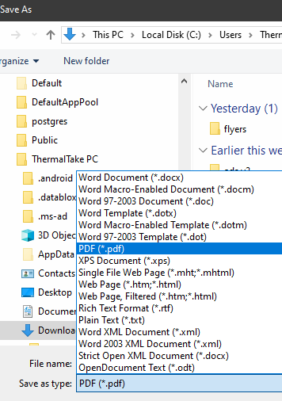Save your work by selecting File > Save
* Save your work as a .pdf by selecting File > Save As option. In the dialog box, choose to save the file as a .pdf
* Upload the file and send a WhatsApp message to:

868-318-7679 or   
868-774-6815

Please allow 24-48 hours for a lecturer to check your submission and get back to you.

Thank you.